EDGE Training exam

Course: Software testing

Question type: Descriptive

No. of questions: 3

Total marks: 20

Time: 1 hour

----------------------------------------------------------------------------------------------------------------------------

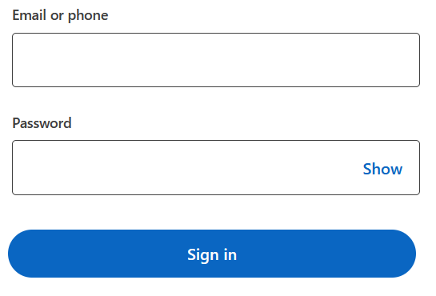**1.** Consider the screenshot of Login page/form

having the following elements:

i) Email or phone text field

ii) Password text field

iii) Sign in button

iv) Show button (for showing password chars)

Write down the possible Functional test cases for the Login page. (10 marks)

**2.** How many Test Levels are there? Write down the name of different levels of testing. (4 marks)

**3.** One of the fields on a form contains a text box that accepts numeric values in the range of 1 to 100.

Identify the Equivalence partitioning and Boundary value for this. (6 marks)